PAPER TITLE (ARIAL 14pt, UPPERCASE, CENTERED, MAXIMUM 2 LINES, STYLE: PAPER TITLE)
Dr. FIRST Author, Dr. SECOND Author, SURNAME Name, SURNAME Name
Some Institution, Some Institute
Some section
Abstract: This is where the abstract text comes. This is a sample text. The text of the abstract should be a maximum of 200 words, about 1200 characters. Style is "Abstract" Times New Roman 11pt, Italic. This is where the abstract text comes. This is a sample text. The text of the abstract should be a maximum of 200 words, about 1200 characters. Style is "Abstract" Times New Roman 11pt, Italic. This is where the abstract text comes. This is a sample text. The text of the abstract should be a maximum of 200 words, about 1200 characters. Style is "Abstract" Times New Roman 11pt, Italic. This is where the abstract text comes. This is a sample text. The text of the abstract should be a maximum of 200 words, about 1200 characters. Style is "Abstract" Times New Roman 11pt, Italic. This is where the abstract text comes from. This is a sample text. The text of the abstract should be a maximum of 200 words, about 1200 characters. Style is "Abstract" Times New Roman 11pt, Italic. This is where the abstract text comes. This is a sample text. The text of the abstract should be a maximum of 200 words, about 1200 characters. Style is "Abstract" Times New Roman 11pt, Italic. This is where the abstract text comes.
Keywords: keyword1, keyword2, keyword3, keyword4
INTRODUCTION (Times New Roman 12p, bold; Style Title 1)
This paper template is written in English. The paper structure contains the following parts: introduction (problem statements, the field of application, research area), the applied method, results, conclusions, and references.
This text uses Times New Roman font, 12 pt, regular, with a line spacing of 1.15. Text style Plain text. A new paragraph is automatically spaced before you use this template! Do not strike rows of bastards between paragraphs, do not use indents at the beginning of rows.
INFORMATION

The paper must be at least 4 pages, but not more than 10 pages! It includes pictures, tables, a list of references, and author(s) information!

It is a subtitle (Style: Heading2; Times New Roman 12pt, Capitalization, bold)
Do not number subheadings!

It is Heading3 (Style Heading3; Times New Roman 12 pt, bold, italic)
For content traceability, do not use a lower-level subtitle. The writing must be at least 4 pages, but not more than 10! It includes pictures, tables, a list of links, and a mailing address! Footnotes are allowed!

Figures and tables
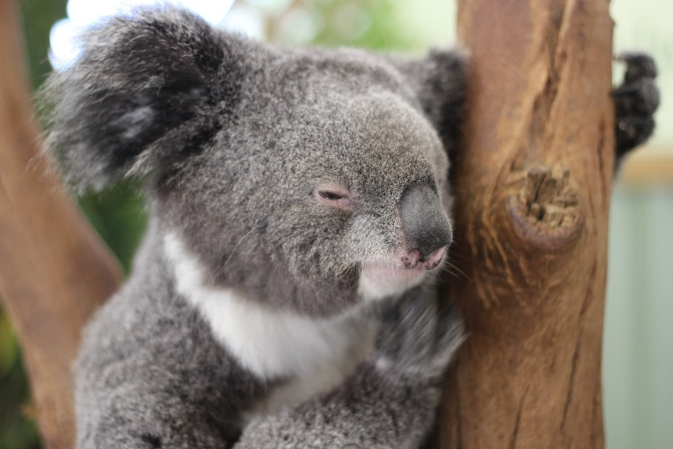
Images should be applied centred! It's good to use a full-width image for your page layout! Ensure the picture is of good quality but does not have a large file extension.
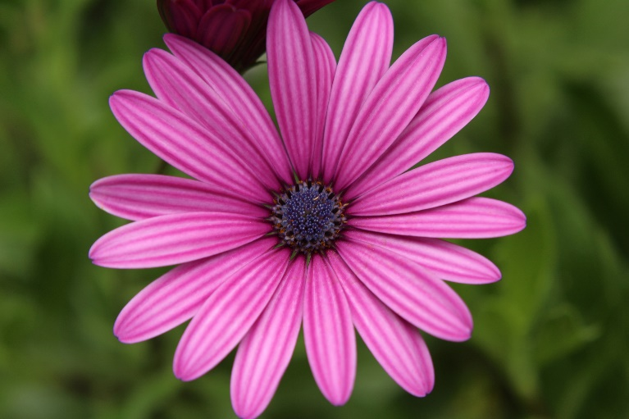
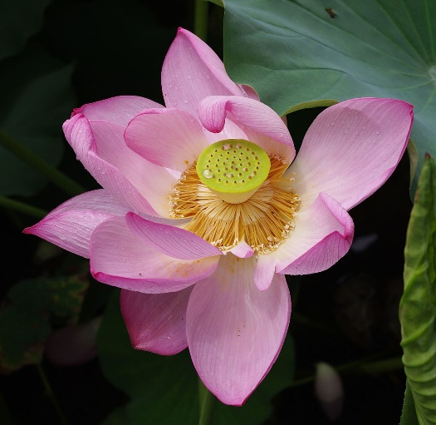
Figure 1: Coala
Figure 2: This is a double-figure where the images are grouped
Table 1: Styles used to create the document
Style name | Typeface | Size | Font version | Line spacing, alignment
Thesis title | Arial Bold | 14 pt | Bold | 1.5 centered
Authors | Arial Regular | 12 pt | Normal | 1.5 centered
Heading 1 | Times New Roman | 13 pt | Bold | 1.5 justified
Heading 2 | Times New Roman | 12 pt | Bold | 1.15 justified
Heading 3 (indent) | Times New Roman | 12 pt | Bold, italic | 1.15 justified
Normal text | Times New Roman | 12 pt | Normal | 1.15 justified
Abstract text | Times New Roman | 11 pt | Normal, italic | 1.15 justified
Figure (Caption) | Times New Roman | 11 pt | Normal, italic | 1.15 centered
Table | Times New Roman | 11 pt | Normal | 1.15 left

Managing the references
References should be indicated in the text by a sequence number in square brackets. [1] They should be numbered in the order in which they appear in the text.
- ISBN/ISSN numbers should be provided where they have been allocated.
- For books, the place of publication is also required.
- The list at the end of this specimen paper contains examples of the referencing of various journals, conferences, books, and other references, the style of which should be followed in preparing your report.
- For three or more authors: Surname of the first author, N., and "et al.".

REFERENCES
[1] | Fórián, S. (2007): Urbanizációs folyamat és annak néhány hatása a környezetre, Debreceni  Műszaki Közlemények, Debrecen 2007/1
[2] | Öllős, G. (2012): Környezetvédelem, Új Levédia Kft.
[3] | World Felder, R. M. – Silverman, L. K. (1988): Learning and Teaching Styles in Engineering Educatio, Engineering Education, 78(7), p674-681
[4] | Jarvis, P. (1987): Adult Learning in the Social Context, Routledge, London, p272

Author(s): (For multiple authors, use multiple similar tables in rows below each other)
Title Name SURNAME
The full title of the Institution
Street, ZIP-code City, Country
Phone: +(area code) (city code) number | E-mail: valami.valaki@valami.valami.edu

The footnote (font size and style is automatic, Times New Roman 10pt) is different from the link! A footnote is used when you want to provide more information about what you can read in the main text, you want to explain something, but it does not belong to the body text. here I can describe that the page image is well influenced by the carefully positioned, harmonious color scheme.
For example, do not put a 1.5 MB image in the text!

