title of the paper (ARIAL, 14 pt, bold)
Name SURNAME¹, Name SURNAME² (Arial, 12 pt.)
¹Institution (Arial, 10 pt.)
²Institution (Arial, 10 pt.)
Abstract:
(Times New Roman, Italic, 11 pt.) The abstract should not be longer than 200 words.
Keywords:
(Times New Roman, Italic, 11 pt.) List 3-6 keywords.
- Introduction (TIMES NEW ROMAN, 11 pt., CAPITAL LETTERS, BOLD)
The paper must be written in English. It should be structured in the following way: INTRODUCTION, EXPERIMENTAL, RESULTS, discussion, conclusionS and references. (Times New Roman, 11 pt.).
- INFORMATION (TIMES NEW ROMAN, 11 pt., CAPITAL LETTERS, BOLD)
Papers must be prepared in camera-ready form for publication. The minimum number of pages is 4, but the paper is restricted to a maximum of 10 A4 pages. The file size of the paper should not exceed 5 MB (if it happens, please check the size of digital images in the figures). The margin settings are 2.5 cm on the Left and Right and 2 cm on the Top and Bottom of the page.
Layout and format (11 pt. bold)
Please use this template for writing your paper; the formatting and font types are automatically adjusted. If an error occurs, please use the following guidelines:
Use A4 Format (297 x 210 mm).
The paper has to be submitted in Microsoft Word document format.
- MAIN HEADINGS (11 pt., bold, capital letters, left justified)
The main headings should be in BOLD CAPITAL LETTERS, 11pt, with the left-hand margin.

Subsidiary headings
They should be in bold letters with initial capital only and separated from the following text with one blank line. Max. 3 subsidiary headings!
- FIGURES, TABLES AND EQUATIONS
Figures, i.e. illustrations and pictures, should be set into the body of the text at the appropriate point, close to where they are referenced in the text and not grouped together at the end of the paper. Place the pictures between paragraphs and centre them between the margins. The figure layout should be in line with the text. Figures should be made in high quality suitable for reproduction and print. The notations on figures must be clearly readable. They must be numbered using Arabic numbers. Figure captions should be written below each figure.
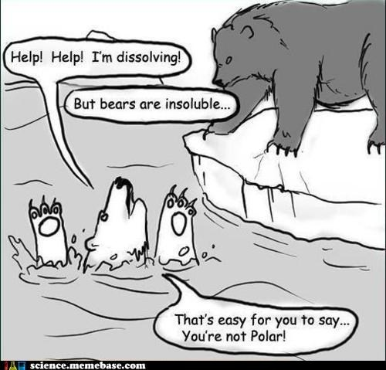
- Title of the figure (Times New Roman, 11 pt, italic, centred)
Place tables as close as possible to the first reference to them in the paper. They must be numbered using Arabic numbers. The title of the table should be written on the top, centred.
- Styles in use in the preparation of this document (Times New Roman, 11 pt, centred)
Header
Data
There should be one-line spacing after the table.
Equations should be centred and numbered consecutively, from 1 upwards. Use Microsoft Equation Editor. There should be one-line spacing before and after the equation.
$Q=c⋅m⋅ΔT$ (1)
- REFERENCES
References should be listed at the end of the text. The text should indicate references by a sequence number in square brackets [1]. They should be numbered in the order in which they appear in the text. All references should be complete so that they can be found by anyone wishing to follow them up. ISBN/ISSN numbers should be provided where they have been allocated. For books, the place of publication is also required. Please follow the examples:
References
- Surname, N.; Surname, N.: Name of Book (in Italics), Publisher, ISBN, Place of Publication, (YYYY)
- Surname, N. & Surname, N.: Name of paper or Chapter, In Name of Book (in Italics), Publisher, ISBN, Place of Publication, (YYYY), pp. xxx-yyy
- Surname, N.; Surname, N. & Surname, N.: Title of conference paper, Proceedings of xxx xxx, Surname, N. (Ed.), pp. xxx-yyy, ISBN, conference location, Month and Year, Publisher, City, (YYYY)
- Surname, N.: Name of paper, Name of Journal (in Italics), Vol. (YYYY) No., pp. xxx-yyy, ISSN
- Surname, N.; Surname N. & Surname N.: Name of Paper, Available from http://www.exact-address-of-site Accessed: YYYY-MM-DD
(For three or more authors, use the SURNAME, N. of the first author plus “et al.”).
- SENDING THE PAPER
Please use the surname of the first author and the event title to identify your file, e.g. Name_SURNAME_YOURSECTION_IJCELIT2025.doc, and send it to the scientific coordinator of the conference: Prof. (hc) Dr. Csaba Horváth; E-mail: horvath.csaba@uni-obuda.hu
- ADITIONAL DATA ABOUT Authors
At the end of the paper, give the information of the corresponding author:
Corresponding author:
Name SURNAME
Department/Laboratory, Faculty, University/Company
Address of Institution/Company
Postal code, City, STATE
Phone:
E-mail:

